*The Ceiling Collapses and Everyone Dies*

Game Design Document

|  |  |
| --- | --- |
| ***Spicy Gnomes* Developer Roster** | |
| **Team Member** | **Role** |
| Daniel Cortell | Producer / Programmer |
| Derrick Roman | Programmer |
| Michelle Truong | Programmer |
| Dexavier Chang | Programmer / Sound Designer |
| Tyler Hughes | Lead Artist / Rigger / Animator |
| Louis Prieto | 3D / 2D / Texture Artist |
| Kyle Lewis | 3D Artist / Designer |
| Alicia Stamps | 3D / Texture Artist |
| Marcus Thinn | 3D / 2D / Texture Artist |
| Lauren Johnson | 2D / UI / Texture Artist |
| Rebekah Kissoon | 2D / 3D / Texture Artist / Sound Designer |
| Kevin Geraldo | Level Designer / UI Designer |
| Young Huang | Lead Programmer / UI Designer |

Overview

High Concept

Gameplay Summary

Features

Genre

Scope

Gameplay and Mechanics

Core Mechanics

Gameplay Systems

Progression

Level Structure

Objectives

Minions

Companion AI

Narrative

Story

Settings and Aesthetics

Levels and Areas

Characters

User Interface

Controls

UI Elements

Sound

Sound Effects

Music

Voice Acting

# **Overview**

## **High Concept**

**Create the ultimate dungeon or raid it for all its treasure!**

Choose a side: the crafty Sorcerer or the haughty Adventurers. As the Sorcerer, use your wits and strategic thinking to defend your artifacts and kill those pesky Adventurers, and get them out of your home! As the Adventurers, raid the Sorcerer’s unpredictable domain and work together to brave his challenges, steal his precious artifacts, and make out like bandits! But take care: as you claim your loot, the Sorcerer grows stronger...

* Bravery: Infiltrate an ominous dungeon to fight a powerful sorcerer.
* Panic: Traverse the dynamic dungeon filled with creatures and traps.
* Teamwork: Band together as a mighty fellowship of heroes.
* Comradery: Fight alongside two other friends as diverse heroes.
* Skill: Utilize a unique set of abilities for each hero or sorcerer.
* Power: Control the rules of your dungeon with spells, traps, and monsters.
* Wit: Outsmart the heroes with unique abilities and trap placements.
* Challenge: Battle it out in an epic 3 versus 1 gameplay experience.
* Competition: Compete against friends to raid or defend the dungeon.

## **Gameplay Summary**

*The Ceiling Collapses and Everyone Dies* is a game where up to three players play as Adventurers trying to steal powerful relics from another player, the Sorcerer, who is trying to protect them and defeat the Adventurers. Those looking to play alone are given the option to battle AI adventurers as the Sorcerer or lead AI teammates into the dungeon as an Adventurer with enhanced abilities.

## **Features**

* Strategic and intense 3v1 action.
* Select various levels set in unique environments.
* Customizable character abilities that increase in power through in-game item pickups.
* As the Sorcerer, traverse your custom-made dungeon from above and rain spells down upon the invading adventurers! Collapse the ceiling to deny them access to certain areas!
* As the Adventurers, work together to steal the Sorcerer’s relics and force him to fight you on equal grounds! Be careful, though: the more relics you possess, the stronger he becomes!

## **Genre**

*The Ceiling Collapses and Everyone Dies* is a multiplayer, isometric, asymmetrical Dungeon Crawler for up to four players. The game is developed with Unity 2019.2.9f1 and will release on PC and Xbox.

## **Scope**

There are three planned levels in three separate locations. Each location has a differently themed Sorcerer with abilities unique to each theme, as well as five planned minions per unique location. There are three planned Adventurer classes with four unique abilities, with each ability having two variations.

# **Gameplay and Mechanics**

# **Core Mechanics**

The game’s core mechanics can be separated into two categories: **Movement** and **Combat**.

**Movement** is simple, with players being able to navigate the rooms of each dungeon with the left analog stick, which allows them to aim their abilities freely with the right stick.

**Combat** is ability-based, with every class and the Sorcerer having four unique abilities that they can cast on cooldown. (Once the Sorcerer has all four of his abilities) Each ability will be assigned to a different button on the controller and will be usable independent of each other.

|  |  |  |  |  |
| --- | --- | --- | --- | --- |
|  | Ability 1  (A button) | Ability 2  (B button) | Ability 3  (X button) | Ability 4  (Y button) |
| Knight | **Block**  Holds Knight in place and greatly reduces incoming damage  **Fortified Armor**  Slows Knight and slightly reduces incoming damage | **Jab**  Light stab with high attack rate that deals low damage  **Cleave**  Strong swing with low attack rate that deals low damage | **Charge**  Buff nearby allies, granting them movement speed  **Intimidate**  Nerf nearby enemies, lowering their movement speed | **Taunt**  Force nearby enemies to attack the Knight  **Fear**  Force nearby enemies to stay away from the Knight |
| Witch | **Fireball**  Deals high damage exploding projectiles at range in an area if it hits a target  **Split-ball**  Spreads five projectiles in a fan-shape that deal moderate damage if they hit a target | **Lightning bolt**  Deals high damage to all targets in a straight line  **Arcing bolt**  Fire five bolts that bounce around, damaging enemies they hit | **Chill**  Deal damage to and slow all enemies in a cone  **Ice Wall**  Create a wall that prevents enemy movement and fades after a short time | **Black Hole**  High damage, slow moving projectile that deals damage to all enemies near it  **Void Elemental**  Summon an elemental that fights for you for a short time |
| Cleric | **Projectile Heal**  Heals allies on hit  Stops on objects  **Energy Bolt**  Heals allies on hit  Passes through enemies, damaging them | **Heal Burst**  Area heal centered on Cleric  **Time Warp**  Area buff centered on Cleric, lowers allied cooldowns | **Holy Ground**  Area heal-over-time placed on ground  **Contagion**  Area damage-over-time placed on ground | **Holy Beam**  Channeled beam that heals all allies hit  **Smiting Beam**  Damaging beam that heals all allies hit |
| Sorcerer  (Enchanted Library) | **Ceiling Collapse**  Cause part of the dungeon to collapse, dealing high damage to those hit and blocking an area | **Summon Minions**  Summon a few underlings that automatically attack nearby Adventurers | **Explosive Rune**  Place an explosive trap that activates when an Adventurer passes over it, dealing high damage in an area | **Psychic Scream**  Push all Adventurers within an area away from the Sorcerer |

## **Gameplay Systems**

* **Camera**
  + When the Adventurers enter a room, the camera will center on that room and lock in place. Once the Adventurers move on, the camera will move with them.
* **Room Transitions**
  + A particle radius around doors will represent a radius that all three adventurers must stand in to be transported to the next connected room in that direction. After teleporting, the particles will disappear for a minute, requiring the adventurers to survive in the room against the Sorcerer's and Minions’ attacks before they can go back or change rooms.
* **Player Downing/Death**
  + The adventuring group will have a total of three lives. When an adventurer reaches zero health, they will fall over and be suitable for a revive if they have lives. Once a player dies and there are no lives to revive them, they will enter a ghost state and be able to float around and perform various emotes, unable to interact with the environment.

## **Progression**

When a session begins, players separate into two groups: The **Adventurers** and the **Sorcerer**.

In the Prep Phase, The **Sorcerer** flies above and prepares the dungeon by placing the three artifacts that the Adventurers must claim, then placing traps and minions to defend them.

In the Dungeon Phase, The **Sorcerer** then casts abilities down on the Adventurers in order to impede their progress. He starts with just the ability to collapse certain parts of the ceiling, which can block off various paths. The Sorcerer gains access to an additional ability every time the Adventurers pick up an artifact.

In the Prep Phase, The **Adventurers** prepare for the dungeon by choosing from one of three classes, each with varying strengths and weaknesses, then choosing one variation of each of their abilities.

In the Dungeon Phase, The **Adventurers** then maneuver through the dungeon defeating minions and avoiding Sorcerer’s traps and abilities. They search for the three artifacts and pick them up, then make their way to the exit of the dungeon in order to win.

If the Adventurers claim all three artifacts, the Sorcerer loses their ability to fly, falls into the dungeon, and is vulnerable to attack. Thus, begins the Duel Phase wherein the two parties engage in the final battle, with the winner claiming victory and ending the session.

## **Level Structure**

Each level will have multiple routes for the Adventurers to take and for the Sorcerer to populate with minions and traps. As the Adventurers clear out rooms, they can freely navigate through rooms that are already clear. However, if the Adventurers enter a room that has living minions within it, they will be prevented from leaving that room until they have dealt with the threat. Each level will be themed appropriately and will have unique transitions between rooms.

Our three currently planned levels are laid out below:

*\*The icons in the images are examples of placement the sorcerer can use\**

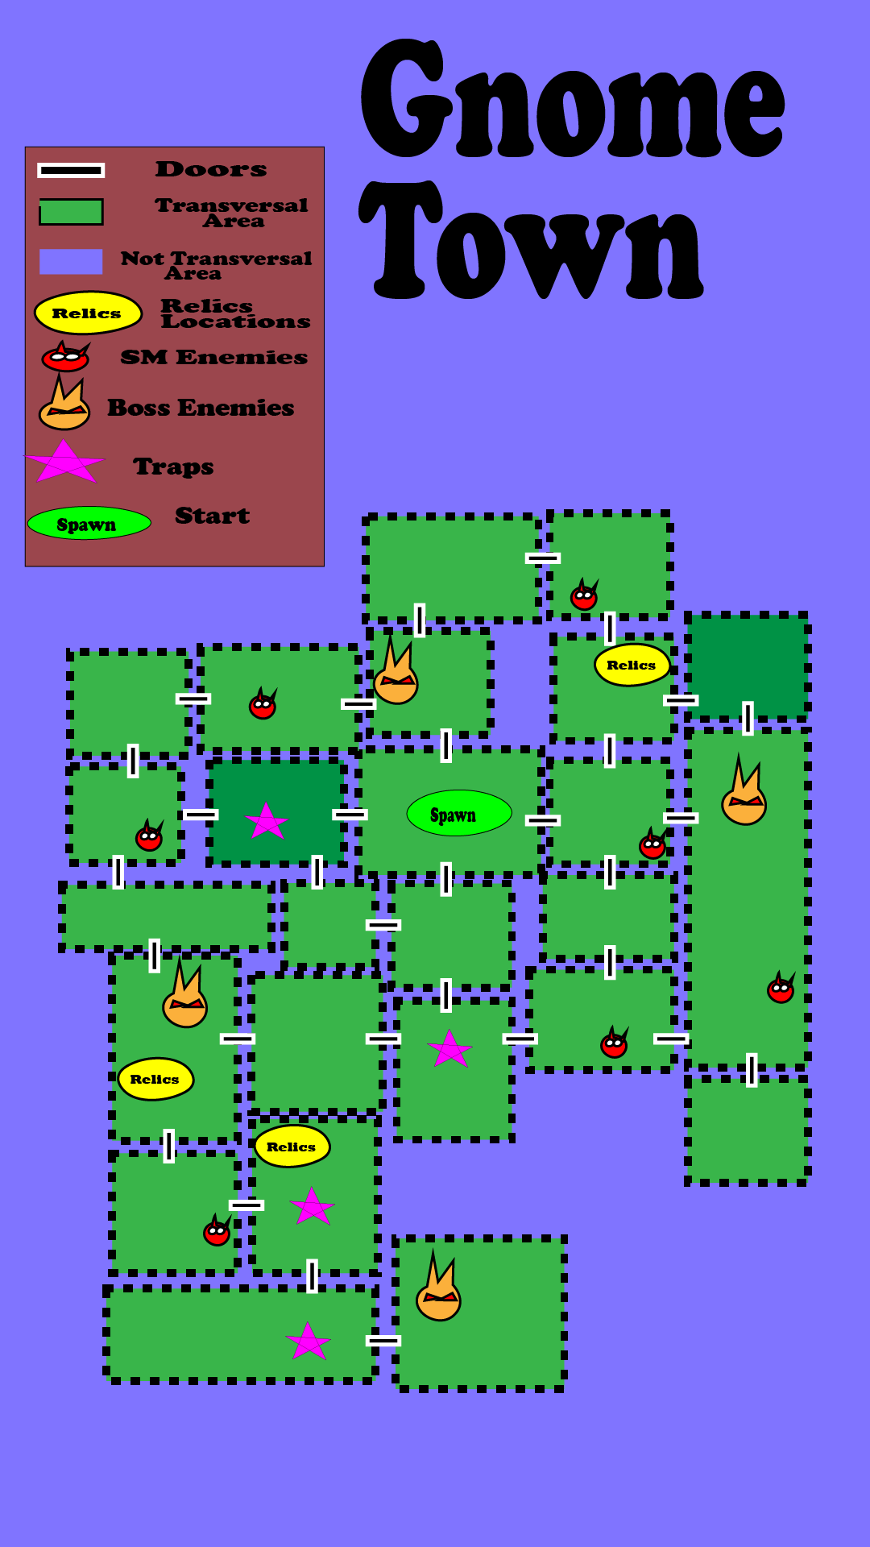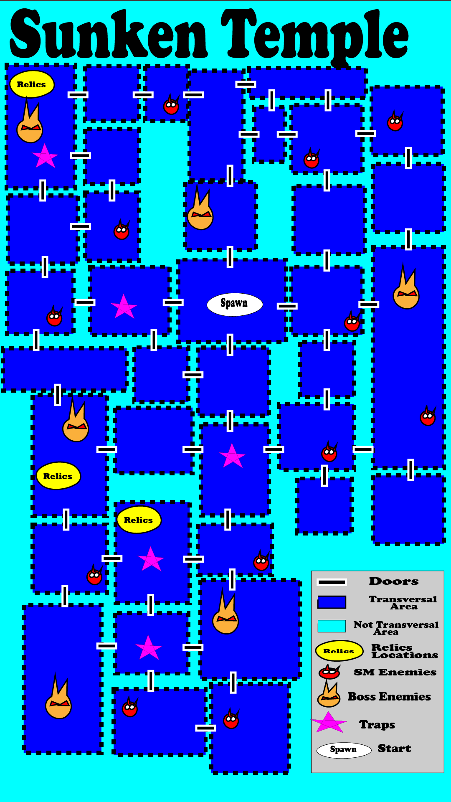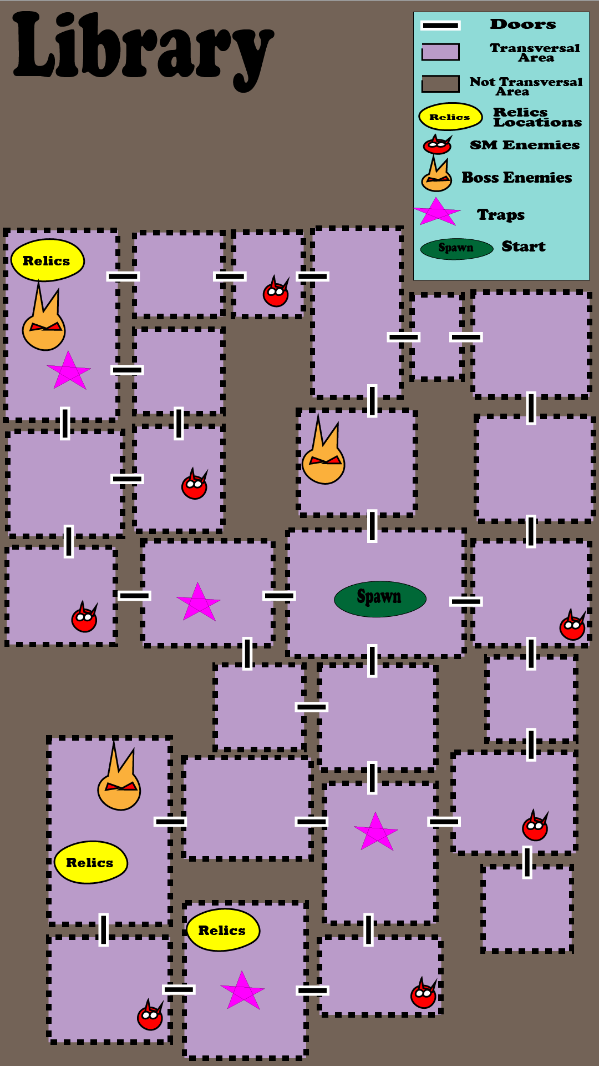

## **Objectives**

The goal of the **Sorcerer** is to defeat the invading Adventurers and prevent them from stealing his precious artifacts.

The goal of the **Adventurers** is to enter the Sorcerer’s domain, steal his artifacts, and defeat the Sorcerer in order to make it out alive and claim their treasure.

# **Minions**

|  |  |  |  |  |
| --- | --- | --- | --- | --- |
| **Name** | **Abilities** | **Behavior** | **Health** | **Damage** |
| **Enchanted Library:** | | | | |
| Mimic | Ravenous Bite  Disguise | Ambush predators that disguise themselves as ancient artifacts to fool travelers. Once a player tries to interact with the false relic, Mimics pounce and attack the closest target mercilessly until the player or the Mimic is defeated. | Medium | High |
| Imp | Fireball | Timid creatures of the night that utilize long range spells. Imps will have a detection cone in front of them, where when the player enters, the Imps will deal damage by hurling balls of fire from a distance. | Low | Medium |
| Slime | Acid Touch | A slow-moving creature made of an acidic, gelatinous material. Slimes feast on any form of flesh they come across but cannot break down tougher materials such as metal and bone. Slimes will have a small detection radius and will deal damage by contact with a mild acid and the weapons lodged inside them from previous meals. | Medium | Low |
| Dragon’s Eye Staff | Crystal Beam | A powerful staff that contains the crystallized eye of an ancient dragon. One of the many artifacts in the Sorcerer's arsenal, this staff harnesses incredible magical energy. The Dragon’s Eye charges up and emits a focused beam of heat that deals damage to all it passes through. It continues to fire as it rotates a full 360 degrees, then stops to charge up for another attack. | Low | High |
| Golem | Seismic Charge | Massive stone brutes animated through the Sorcerer's dark magic, tasked with defending the Library’s secrets. It’ll be a stationary enemy before attacking. When an Adventurer enters its detection cone, the Golem will look at the Adventurers, focusing on the closest one. After a couple seconds of building up, they’ll charge forward a set distance, damaging anything in their path, stopping, and then repeating. | High | Medium |

# **Companion AI**

**The Cleric:** Assists the player with their abilities when in battle or afterwards, focusing on healing their party members rather than attacking. Whenever a player reaches less than 30% health, they will focus healing that party member and cast holy beam.

**The Witch:** Whenever in battle, they’ll cast their long-range abilities such as fireball and lightning bolt towards the enemies that are furthest from them. If enemies are detected in a closer range, they’ll activate their icy wind first, and if enemies are closer still, they’ll then activate their black hole.

**The Knight:** Runs up to enemies, activating their Damage Reduction and Intimidate. While within melee range, the knight will constantly spam their sword attacks and other abilities when available until low on health. When low health, they will activate their fear effect as well as movement speed buff.

# **Narrative**

## **Story**

Three adventurers learn of a mystical Sorcerer who holds three artifacts of vast power and unimaginable value and immediately head off to claim them. The Sorcerer is but an old curmudgeon, tired of doing battle over and over with haughty travelers and has settled down to relax in his home filled with priceless heirlooms. When the adventurers come knocking, the Sorcerer spends the last of his savings on servants and traps to deal with the adventurers so that he doesn’t have to. Unfortunately for him, the Adventurers are resourceful enough that he might just have to get involved anyway.

## **Settings and Aesthetics**

*The Ceiling Collapses and Everyone Dies* takes place in a fantasy world filled with heroes, magic, mythical creatures, and, of course, villains. Discover deep, treacherous dungeons long lost to this world. Heroes hunt for magical artifacts with immense power while fighting unique creatures that populate these treacherous caverns. Villains defend their dark cavernous homes with traps, minions, and powerful spells. What side will you be on?

## **Levels and Areas**

**Enchanted Library:** A large study filled to the brim with magical tomes, enchanted stories, and enough vocabulary to baffle even the most powerful linguists.

**Sunken Temple:** A once beautiful temple now flooded and overrun with sea creatures, dangerous plant life, and the like. Beware of dangers lurking above and below the surface.

**Gnome Town:** A small town in a forest clearing that appears to be under siege by an army of Gnomes. How the town’s guards lost that battle is anybody’s guess.

## **Characters**

**The Sorcerer:** A disgruntled old wizard, tired of constantly having to fight adventurers over his lifetime. A grinch with no care for others, he prefers the life of solitude perfecting his dark arts. He settled down in what he thought would be his home for the first time in a very long time, but his troubles are just getting started.

**The Cleric:** A greedy, self-centered reject from the church of Plutus, kicked out for using her healing magic for monetary gain. She merely needed to hear that there was a monetary reward to sign up for this adventure; it has yet to be seen if her greed and short-sightedness will be her undoing.

**The Witch:** A cute, cheerful, and talented young spellcaster that was blessed with the knowledge of the arcane arts from birth. After outranking all her former teachers, she seeks adventure and friendship with unlikely companions while attempting to discover the secrets of her foggy past.

**The Knight:** A somehow cowardly man raised by an incredibly stalwart family and squire to one of the most accomplished knights in the land. Forced to live up to his family’s impossible standards, he has taken up adventuring to prove himself worthy of his lineage; only time will tell if he has the mettle.

# **User Interface**

## **Controls**

*Main Menu Screen*

* Only player one with the first controller will be allowed to control the navigation on the Main Menu.
* The players will use a controller and navigate through the main menu screen using the left analog stick with the A button as a confirmation and the B button to cancel.
* The user will have multiple options on the main menu, between Play, How to Play, Settings, Credits, and Quit.

*Character Selection Screen*

* The players will be used the left analog stick to choose between characters.
* The Left and Right bumpers will be used in the character selection screen, to view abilities.
* The Y button will be used to ready up in the character selection screen. Once everyone is ready, the game will start.
* The X button will be used to ready up to return to the main menu on the character selection screen.

*Play Mode*

* Sorcerer’s controls
  + The Sorcerer will use the left analog stick to move around in build mode and battle mode.
  + The sorcerer will use the left and right bumper to select between objects to place down in their Hotbar.
  + Once the build mode’s timer has ended or when the sorcerer placed all their items on the map, the game goes to the battle mode and the build mode’s Hotbar will disappear.
  + The sorcerer will have four abilities mapped to A, B, Y, and X during battle mode.
  + Each ability’s UI will unlock after the party has obtained each relic.
  + The start button will be used to access the pause screen.
* Party’s Control
  + The party’s UI will be visible once the game enters battle mode.
  + Each player will be on separate controllers and move around with the Left Analog Stick.
  + Each player will have four abilities, mapped to A, B, Y, and X buttons.
  + The players will have access to Left and Right Bumper that will be used to revive their allies.
  + The start button will be used to access the pause screen.

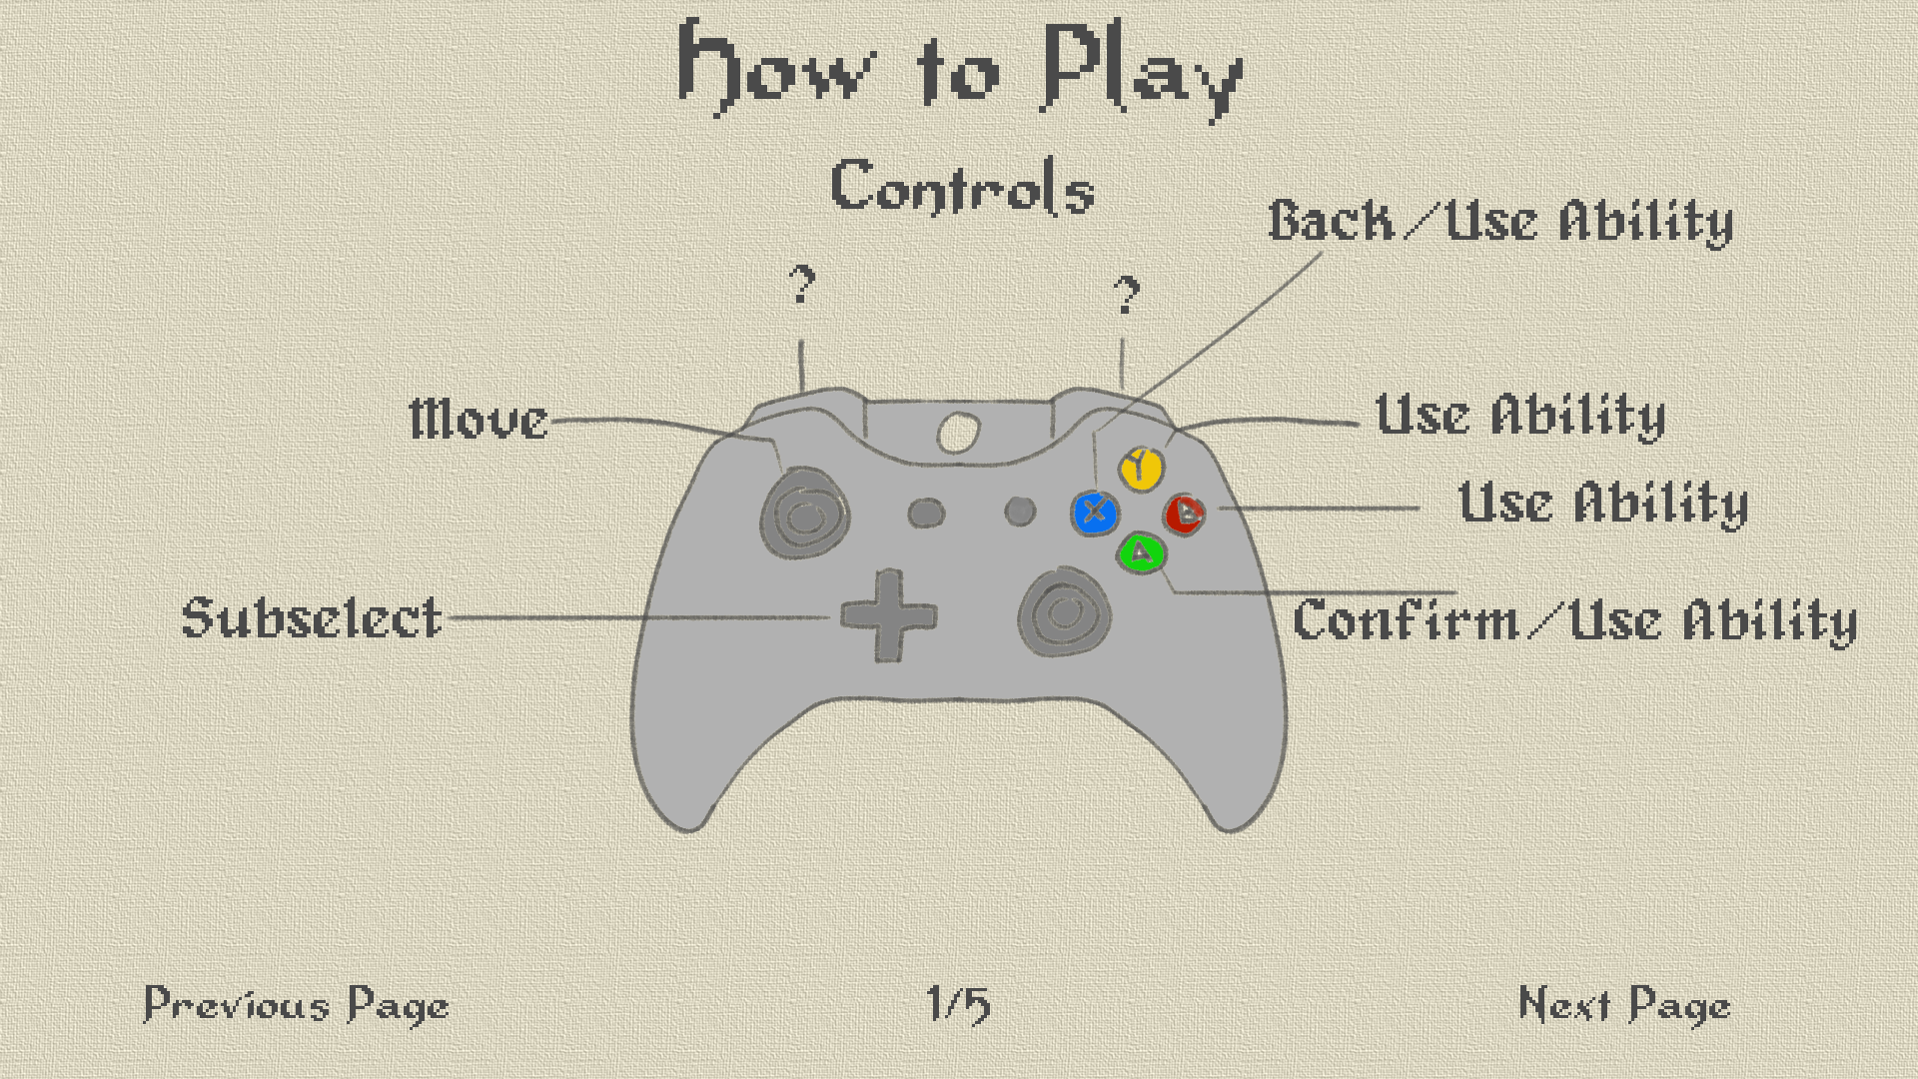

*This image is used as a general description of the in-game controls display. There are multiple uses for certain buttons in different phases of the game.*

## **UI Elements**

**How to Play Screen**

* There are five pages that are an optional read for the player and is used as a tutorial for the players on how to play the game.
* The first page consists of controls to show the general movement and what buttons are used to play the game.
* The second page will show how the Sorcerer’s build mode works and information on how to place items.
* The third page shows the difference in each item that the Sorcerer can place down. This can be used as a guide/glossary for the Sorcerer’s placeable objects.
* The fourth page will be a guide to how to play each of the party characters; the Knight, Cleric, and Witch.
* The fifth page is a continuation of the fourth page, which explains some of the party characters’ roles and sprites showing off their abilities.

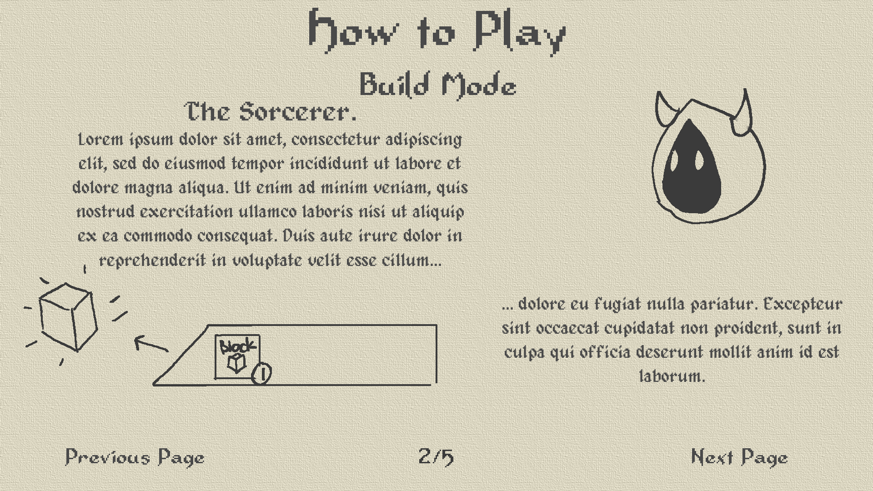

**Character Selection Screen**

* The selection goes from the first controller to the last controller.
* Players cannot cancel their selection on the character selection screen.
* If all the players decide to return to the main menu, they can pass a ready check to return to the main menu. Once the players return to the main menu, the character selection will be reset.
* Once each player has decided their character, they will ready up, a timer will begin, then the game will start.
* For future implementations, after the character selection screen, the Sorcerer player will have the option to pick a map.

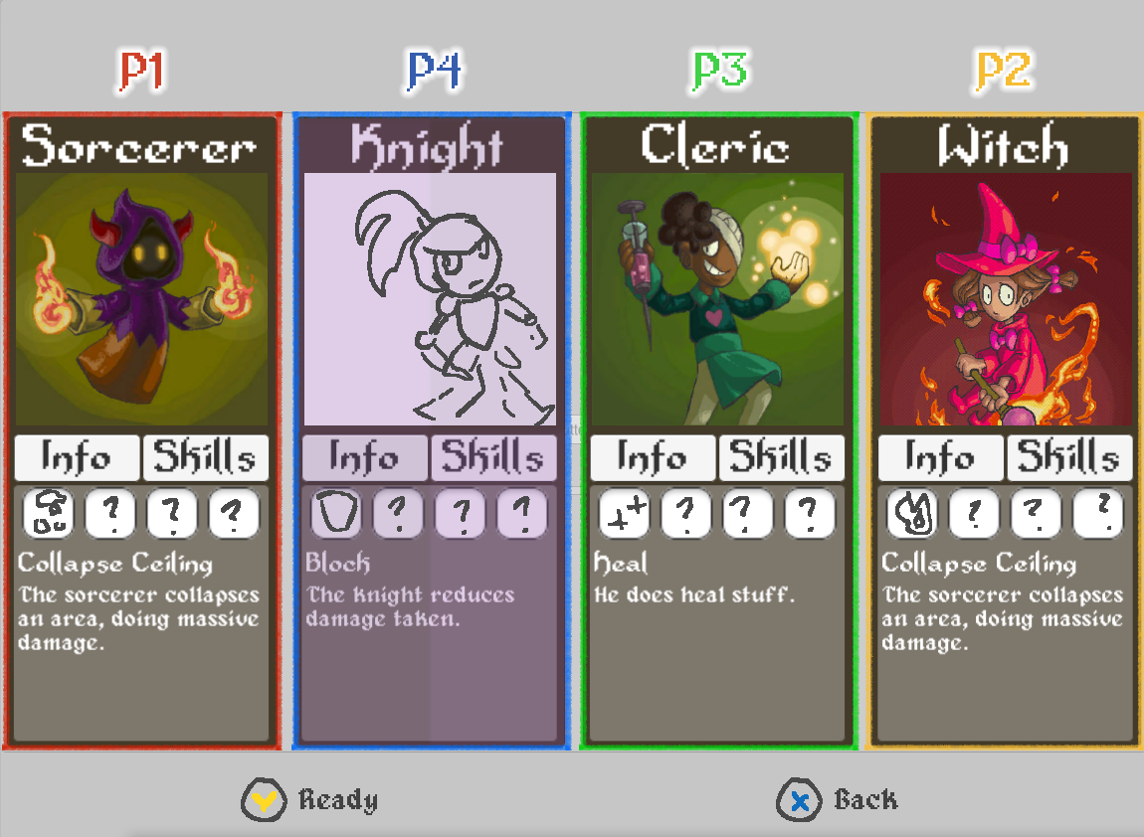

**Game Menu Flowchart**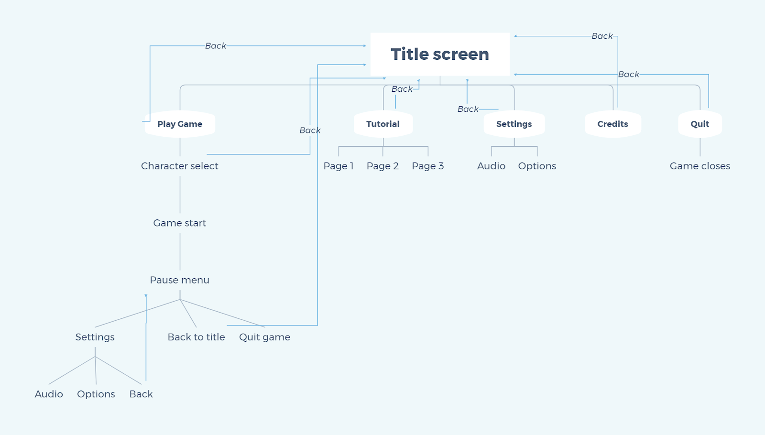

**In Game Mockups**

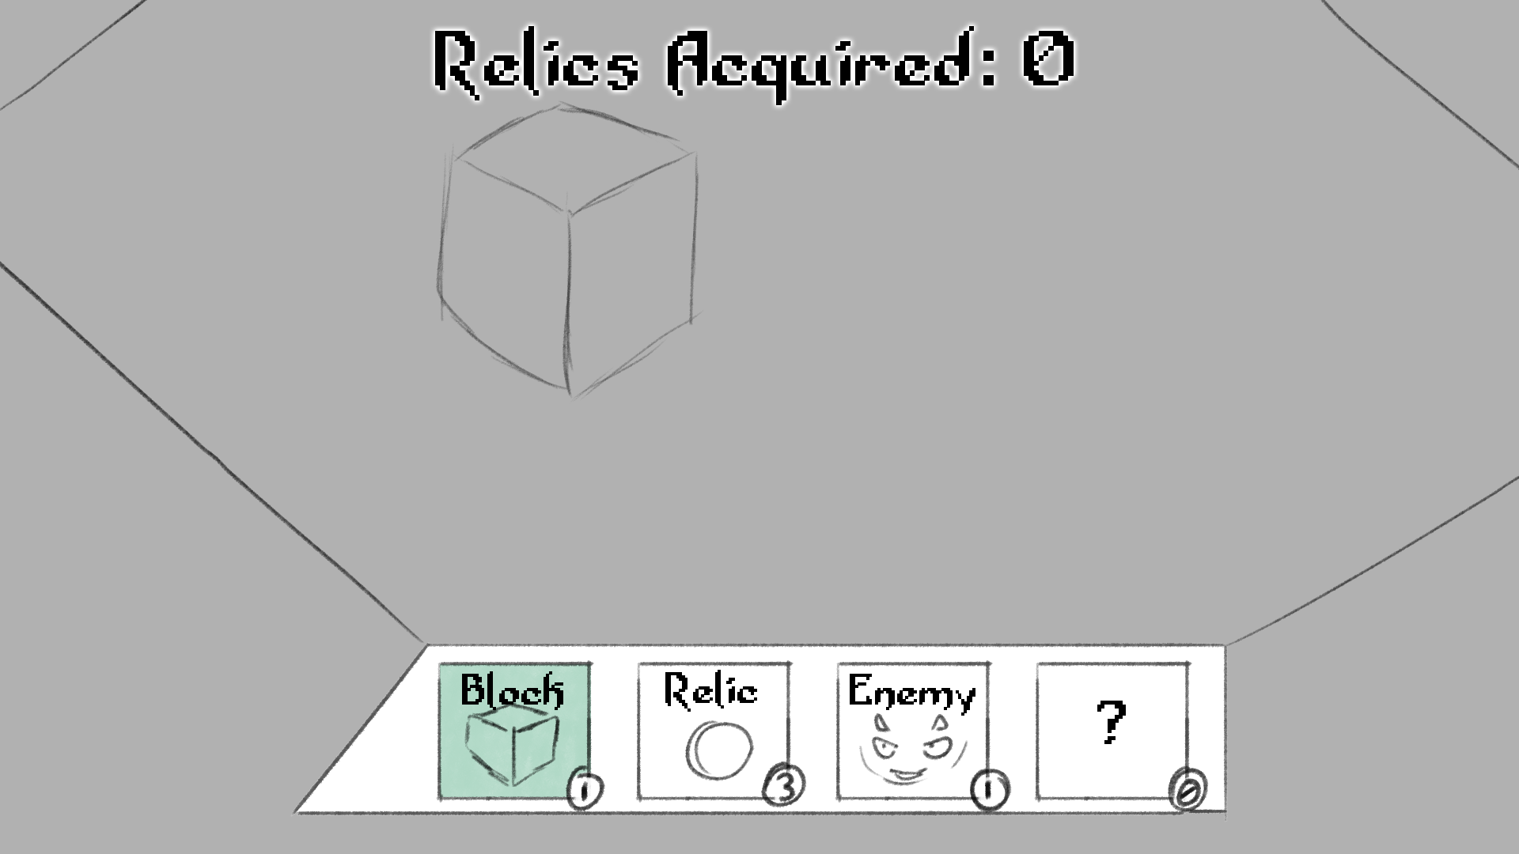

**Build Mode**

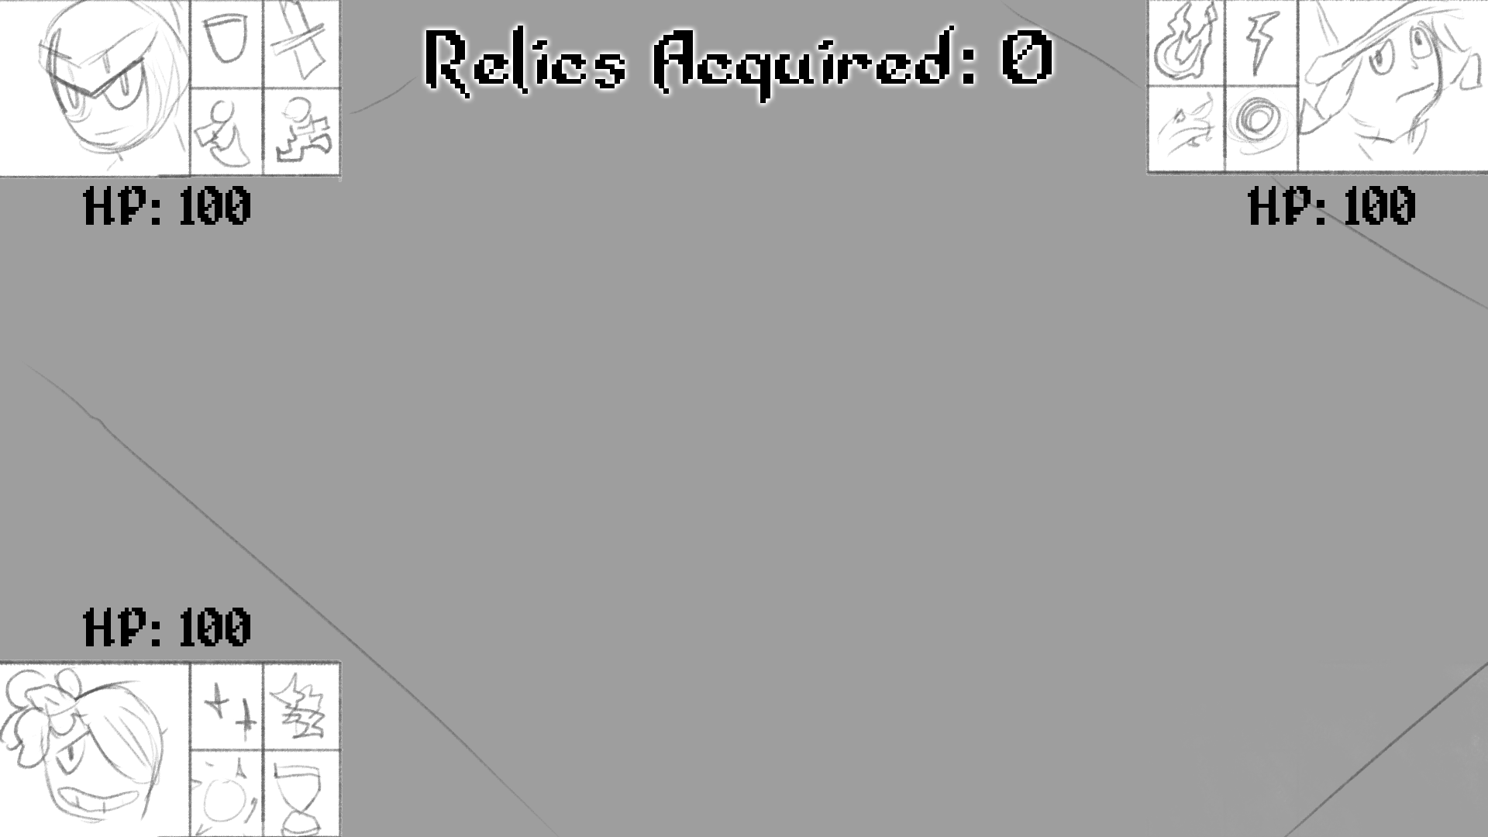

**Battle Mode**

# **Sound**

## **Sound Effects**

All sound effects were created in Audacity.

Witch:

* **Walking:** The Witch’s walking sounds like multiple tiny floor hits.
  + Played on loop every time the player moves the Witch.
* **Fireball/Splitting Fireball:** The fireball sounds like a powerful explosion.
  + Played every time the player presses the A button.
  + On impact an explosion sound is played.
* **Arcing Bolts/Lightning Bolts:** Sounds like a thunderous and powerful roar.
  + Played every time the player presses the B button.
  + For Arcing Bolts, an electrical static or spark sound plays on every bounce / impact with enemy.
* **Icy Wind/Ice Wall:** Sounds like a slight windy breeze.
  + Played every time the player presses the X button.
* **Black Hole/Void Elemental:** A piercing sound that lasts up to five seconds.
  + Played every time the player presses the Y button.

Cleric:

* **Walking:** A bag of coins shaking to emulate his greediness.
  + Played on loop every time the player moves the cleric.
* **Projectile Heal/Energy Bolt:** A twinkling chimes sound plays as the projectile spawns and moves until it hits something.
  + Plays on the press of the A Button.
* **Heal Burst/Time Warp:** A high pitch *whoosh* sound effect.
  + Plays on the press of the B button.
* **Holy Ground/Contagion:** A slow pulsating horn like sounds plays for the duration of the ability.
  + Start on the press of the X button and ends when ability ends.
* **Holy Beam/Smiting Beam:** A pulsating high pitch tone that plays for the duration of the ability.
  + Starts on the press of the Y button and ends when the ability ends.

Knight:

* **Walking:** Sound like metal clanking together.
  + Sound is played every time the player moves the knight.
* **Block/Fortified Armor:** A small shifting sound that indicates the knight is moving into a defensive stance with his shield.
  + Played every time the player presses the A button.
* **Sword Attack/Cleave:** A small wiping sound that indicates the Knight is striking. Cleave will be a lower pitch version of the sword attack sound.
  + Played every time the player presses the B button.
* **Charge/Intimidate:** The Charge is a drum pattern while the Intimidate is a loud battle horn.
  + Played every time the player presses the X button.
* **Fear/Taunt:** Fear is a lower pitch horn of intimate while the Taunt is a nervous laugh.
  + Played every time the player presses the Y button.

Sorcerer:

* **Summon Lackies:** A wave/shimmer like sound plays as a portal opens and enemies jump out.
  + Plays on the press of the B button.
* **Explosive Rune:** A quick crack like sound
  + Plays on the press of the X button.
  + A smoky explosion sound plays when an Adventurer triggers the Rune
* **Psychic Scream:** A harrowing scream that tapers off into a sort of white noise
  + Plays on the press of the Y button.
* **Ceiling Collapse:** The sound of rumbling objects as visuals of bricks shake, then it leads into the sound of them all cascading.
  + Plays on the press of the A button and continues changing at specific visual cues.

Enemies:

* **Mimic:** A toothy comping sound followed by a light clanking sound as it moves to get closer to the adventurers.
* **Imp:** A tiny grumbling sound as they move around
  + Fireball: Same as the Witch’s but a little higher pitch, as the projectiles will be much smaller
* **Slime:** A wet slapping sound as it moves towards the player, turning into a slurping sound when it begins to damage the players.
* **Dragon’s Eye Staff:** Plays a slowly increasing tone before quickly changing into a high constant pitch tone, getting quieter as the ability start to end.
* **Golem:** Sound of grinding stone as the Golem moves to face the closest player. When the Golem charges the player, the sound of pounding akin to a charging elephant will play until it stops to repeat the cycle.

Ambient Sounds

* Creaking Door Opening sound when players transition to a different room
* Door locking sound when the players enter the new room to symbolize that they are locked in
* Door unlocking sound to symbolize when they can move to the next room
* Clinking Relic sound when a Relic is picked up

UI Sounds

* Wood Knocking Sound when moving around the UI
* Sharpening sound when selecting / confirming UI Choices
* Unintelligent babbling to express different character emotions on character selection
  + Sorcerer: Angry toned babbling
  + Witch: Cheerful toned babbling
  + Cleric: Greedy chuckle
  + Knight: Worried moan

## **Music**

All music is made in Garageband using Apple Loops to ensure the ability to loop in-game.

* Main Menu Theme
  + Plays on game start and the Main Menu.
  + Designed to excite players ready to start the game.
* Build Theme
  + Plays during the Prep Phase.
  + Designed to simulate elevator style, idle music while players select their character, and the Sorcerer builds their dungeon.
* Battle Theme
  + Plays while fighting the sorcerer.
  + Intense and fast-paced. Designed to heighten the tension of players in the middle of battle.
* Adventurer Win Theme
  + Plays when the Adventurers win the game.
  + Designed to be lighthearted and boost the morale of the party.
* Sorcerer Win Theme
  + Plays when the Sorcerer wins the game
  + Designed to be like the battle theme but slowed down.
* Library Theme
  + Plays during the Enchanted Library level.
  + Designed to embody the concept of curiosity and gaining knowledge from books.

## **Voice Acting**

Currently, there are few voiceovers, but more lines are planned, and will likely be done in a similar style to Animal Crossing, where dialogue is unintelligible babbling with subtitles providing translation.